

**DEPARTMENT OF Mechatronics and Biomedical Engineering**

**CEP REPORT**

**“Design and Analysis of Scissor Lift Mechanism”**

**Course:**

Design of Machine Element   
**Class/Section:**

BEMTS-F-20-B

**Submitted To:**

Dr. Imran Shah

**Submitted By:**

Muhammad Faiq Nasir (201075)

Muhammad Waleed Tariq (201111)

Saud Mubashir (201147)

**Abstract**

The project focuses on the stress analysis of a scissor lift mechanism, employing both theoretical analysis and software simulation. The aim is to design a structurally sound mechanism capable of lifting a load of 5000 kg while adhering to safety factors and weight constraints. The project involves kinematic analysis, stress analysis, and dimensioning of critical components using knowledge from Statistics, Mechanics of Materials, and Machine Design. The scissor lift mechanism is analyzed using static structural analysis software, to evaluate its structural integrity. Maximum Equivalent stress, total deformation and factory of safety were found using Finite Element Analysis. The theoretical analysis and software simulation provide valuable insights into the structural behavior and performance of the scissor lift mechanism. The project highlights the importance of stress distribution, deformation, and Factor of safety in ensuring the design's reliability and functionality. It emphasizes the significance of incorporating safety margins and weight optimization without compromising structural integrity. The conclusions drawn from the project indicate that the scissor lift mechanism is well-designed and capable of withstanding the intended loads. However, further validation through physical testing and compliance with industry standards are recommended for practical implementation. Overall, the project contributes to the understanding of stress analysis in the context of mechanics of machines and demonstrates the use of theoretical knowledge and software tools to design and evaluate robust mechanical systems.

**TABLE OF CONTENTS**

1. Problem Statement 6

2. Objectives 6

3. Introduction 7

4. Types of Scissor lift mechanism 8

5. Main Components of Scissor Lift 10

6. Concepts involved 10

7. Design Constraints 12

8. Weight Optimization: 13

9. Kinematic analysis 13

9.1. Hydraulic cylinder 14

9.2. Scissors lift 14

9.3. Design of Scissor Arm 15

9.4. Forces on Beam 16

10. Theoretical Results 18

11. Software Modelling and analysis 22

11.1. CAD model 22

11.2. Finite Element Analysis – ANSYS 25

11.3. Evaluation of Software Results 29

12. Mesh Independence 30

13. Conclusion 30

14. Physical Applications 30

15. References 33

**List of Figures**

Figure 1Base Platform CAD Model ........................................................................................ 20

Figure 2 Scissor Arm CAD Model........................................................................................... 20

Figure 3 Lifting Platform CAD Model .................................................................................... 21

Figure 4 Support Hinge CAD Model ....................................................................................... 21

Figure 5 Scissor Arm Hinge CAD Model ................................................................................ 22

Figure 6 Centre Pin CAD Model ............................................................................................. 22

Figure 7 Connector Pin CAD Model ....................................................................................... 22

Figure 8 Roller CAD Model .................................................................................................... 22

Figure 9 CAD Model of Scissor Lift Mechanism .................................................................... 23

Figure 10 Mesh Generation on Model ..................................................................................... 24

Figure 11 Boundary Condition - Static Strucural .................................................................... 24

Figure 12 Solution - Equivalent Stress .................................................................................... 25

Figure 13 Solution - Total Deformation ................................................................................... 25

Figure 14 Solution - Factor of Safety ...................................................................................... 26

**“Design and Analysis of Scissor Lift Mechanism”**

# Problem Statement

The purpose of this project is to perform stress analysis and design optimization for a scissor lift mechanism used in the field of Mechanics of Machines.

# Objectives

Main Objectives of this project are:

1. **Design a scissor lift mechanism:** Develop a well-designed scissor lift mechanism based on thorough kinematic analysis, considering factors such as link lengths, joint types, and constraints.
2. **Perform stress analysis:** Apply principles of Statistics, Mechanics of Materials, and Machine Design to analyze the critical components of the scissor lift mechanism under various loading conditions and determine their stress levels.
3. **Identify critical components:** Identify the components that are subjected to high stress levels and require careful design consideration to ensure structural integrity and longevity of the scissor lift mechanism.
4. **Dimension the components:** Determine the appropriate dimensions for the critical components, considering the applied loads, material properties, and desired factor of safety. Optimize the design to maintain a low overall weight while ensuring strength and stability.
5. **Incorporate factor of safety:** Incorporate a factor of safety (F.S) of 1.3 in the design to provide a margin of safety against failure and ensure the scissor lift mechanism can withstand the intended load capacity of 5000 kg.
6. **Simulate the design:** Utilize computational tools and software to simulate the behavior of the scissor lift mechanism, validate its performance, and identify any potential issues or areas for improvement.

By achieving these objectives, the project aims to deliver a well-designed, structurally sound, and optimized scissor lift mechanism that can efficiently lift and support the desired loads while maintaining a high level of safety and reliability.

# Introduction

Scissor lifts are lifting devices, which employ scissors mechanism to raise or lower goods or people through relatively far distances. A choice of lift devices is made based on three main criteria: lifting height, lifting weight, and lifting equipment according to the drive devices.

There have been many layouts of scissor lifts concerned with the arrangement of the cylinder. These dimensions involve the working space of lifts and the operation of cylinders; they play an important role in the platform movement. There have been studies dealing with studying scissor lifts, some of which focus on simulation software to evaluate the operation of the system or calculated strength of component lift to determine suitable design dimensions. However, there have been few studies dealing with the arrangement of cylinders or construction of the specific equation to calculate thrust force for cylinders.

# Types of Scissor lift mechanism

There are various types of scissor lift mechanisms. These mechanisms differ in their configuration, motion, and lifting capabilities. Some of the commonly used types are:

1. **Single Scissor Lift:** 
   * This is the most basic type of scissor lift mechanism, consisting of a single set of linked scissor arms.
   * It provides vertical lifting motion by extending and retracting the scissor arms in a linear fashion.
   * Single scissor lifts are commonly used for low to medium load capacities and relatively smaller lifting heights.
2. **Double Scissor Lift:** 
   * A double scissor lift mechanism consists of two sets of linked scissor arms stacked on top of each other.
   * This configuration provides increased lifting height compared to a single scissor lift.
   * Double scissor lifts are suitable for applications requiring higher lifting heights while maintaining a compact design.
3. **Multi-Scissor Lift:** 
   * Multi-scissor lift mechanisms involve multiple sets of linked scissor arms placed in series.
   * This configuration allows for even greater lifting heights and increased stability.
   * Multi-scissor lifts are often used in applications requiring extensive vertical travel and higher load capacities.
4. **Cantilever Scissor Lift:** 
   * In a cantilever scissor lift mechanism, one end of the scissor arms is fixed while the other end extends outward.
   * This design provides a cantilevered platform that can reach over obstacles or work in tight spaces.
   * Cantilever scissor lifts are commonly used in automotive maintenance, construction, and aircraft maintenance applications.
5. **Tandem Scissor Lift:** 
   * Tandem scissor lifts consist of two or more scissor lift platforms operating in tandem.
   * The platforms move simultaneously and offer increased load capacity and stability.
   * Tandem scissor lifts are often used in heavy-duty applications, such as lifting heavy machinery or vehicles.
6. **Articulating Scissor Lift:** 
   * An articulating scissor lift mechanism incorporates additional joints or pivot points within the scissor arms.
   * This allows for improved maneuverability and access to confined spaces.
   * Articulating scissor lifts are commonly used in industries such as construction, maintenance, and warehousing.

These are just a few examples of the different types of scissor lift mechanisms. The choice of the specific mechanism depends on factors such as the required lifting capacity, height requirements, space constraints, and application-specific needs.

# Main Components of Scissor Lift

The main components of the lift are:

1. Hydraulic Cylinder
2. Top-platform
3. Scissor Arm
4. Base support frame
5. Support hinges
6. Rollers

# Concepts involved

The project involves several key concepts from various engineering disciplines. The following concepts are involved:

**a) Kinematic Analysis:**

The project requires a thorough understanding and analysis of the kinematics of the scissor lift mechanism. This involves studying the motion, geometric relationships, and constraints within the mechanism to ensure proper functioning and desired performance.

**b) Stress Analysis:**

We are expected to perform stress analysis using principles from Mechanics of Materials. This involves analyzing the internal stresses and forces exerted on the critical components of the scissor lift mechanism to ensure their strength and durability. The analysis considers factors such as applied loads, material properties, and design constraints. **c) Statistics:**

Statistical concepts are utilized in the project to incorporate a factor of safety (F.S) of 1.3 in the design. The factor of safety provides a margin against failure and ensures that the scissor lift mechanism can withstand the anticipated loads and operating conditions.

1. **Machine Design:**

The project requires participants to apply the principles of machine design to develop an efficient and reliable scissor lift mechanism. This involves considerations such as component selection, dimensioning, material choices, and overall system optimization to meet the project's load capacity and factor of safety requirements.

1. **Weight Optimization:**

The total weight of the scissor lift structure is a crucial consideration in the project. Participants are tasked with minimizing the weight while maintaining the structural integrity of the mechanism. Weight optimization helps enhance the efficiency, portability, and overall performance of the scissor lift.

1. **Computational Tools and Simulations:**

Participants are expected to employ computational tools, such as finite element analysis (FEA) software, and perform simulations to validate the design and analyze stress distribution. These tools aid in optimizing the scissor lift mechanism and provide valuable insights into its behavior under various operating conditions.

1. **CAD Modeling:**

Computer-Aided Design (CAD) software is used to create detailed models and drawings of the scissor lift mechanism. CAD models help visualize the design, assess clearances, and facilitate the generation of manufacturing drawings.

# Design Constraints

Design Constraints for the project are:

1. **Kinematic Analysis:** 
   * The scissor lift mechanism must be designed based on thorough kinematic analysis.
   * Motion, geometric relationships, and constraints within the mechanism should be considered to ensure proper functionality.
2. **Stress Analysis:** 
   * The design of the scissor lift mechanism should incorporate stress analysis principles.
   * Knowledge of statistics, mechanics of materials, and machine design should be utilized to analyze the stresses and forces on critical components.
3. **Identification of Critical Components:** 
   * The group must identify critical components that require detailed design consideration.
   * Sufficient knowledge and expertise should be applied to select and analyze these components effectively.
4. **Load Capacity:** 
   * The scissor lift should be capable of safely lifting a load of 5000 kg.
   * The design should ensure that the mechanism can handle the specified load without compromising its integrity.
5. **Factor of Safety:** 
   * A factor of safety (F.S) of 1.3 must be incorporated into the scissor lift design.
   * The factor of safety provides a margin against failure, ensuring the mechanism's

reliability and safety.

# Weight Optimization:

* + The total weight of the scissor lift structure should be kept as low as possible.
  + Weight optimization is essential to enhance the efficiency, portability, and overall performance of the scissor lift mechanism.
  + The design should adhere to permissible design variables while maintaining the structural integrity of the mechanism.

These design constraints help to develop a scissor lift mechanism that incorporates kinematic analysis, stress analysis, and design optimization principles. The resulting design should meet the load capacity requirements, factor of safety, and weight optimization considerations while ensuring the integrity and efficiency of the mechanism.

# Kinematic analysis

In this section, all design concepts developed are discussed and based on evaluation criteria and process developed, and a final here modified to further enhance the functionality of the design.

## Hydraulic cylinder

The hydraulic cylinder is mounted in an inclined position.

The total load acting on the cylinder consists of:

* Mass to be put on the lift = 500 kg.

Taking FOS = 1.5 for mass in pallet 3000 x 1.5 = 4500 kg

* Mass of top frame= 460 kg
* Mass of each scissor arm = 63.57 kg
* Total mass of four Scissor arms = 254.308 kg
* Mass of links of cylinder mounting = 8 kg
* Mass of cylinder = 18kg
* Total Mass = 5266.308 kg
* Total load = 5266.308x 9.81 = 51662.48N

## Scissors lift

For a scissor lift Force required to lift the load is dependent on, Angle of link with horizontal Mounting of cylinder on the links The length of the link.

Formula used

Where W = Load to be lifted

**S= a2 + L2-2aLcos α**

S = Distance between end points of the cylinder L= length of Scissor arm= 4.2 m

α = angle of cylinder with horizontal

Now the maximum force will act on the cylinder. When the cylinder is in shut down position i.e., when the scissor links are closed.

For calculations, we will consider α=300

Now substituting α= 300,

F=51662.48 N

Selecting 70 mm bore diameter of the cylinder

Area of the bore of the cylinder

A = (3.14×702)/2=3848mm2

Pressure=(Force/Area) = (51662.48/3848×106) = 134.2 bar

## Design of Scissor Arm

For the link design, it has been considered that the entire load is acting on half of the length.

We set the length of the entire arm = 4200mm.

So length of the link considered as the beam for the calculation purpose = 2100mm.

Hence, the load pattern on the scissor arm is uniformly varying load (U.D.L) due to its inclination with horizontal. The calculation is done for the scissor arm in shut height position, i.e., when the angle made by the arms with horizontal is 300. The length of the pin from the intermediate pin to the bottom roller is considered as a beam.

## Forces on Beam

The force acting on the beam are:

1. The reaction offered by the base to the roller, RA resolved into 2 components.
2. The reaction offered by the intermediate pin, HB, VB.

The force due to (Payload + Platform weight) resolved into two components, along with the length of the arms and perpendicular to the length of the scissor arm.

Now Let,

Hy0 =Mass applied on the lift = **4500kg**

B=Mass of the lift which the cylinder needs to lift = **766.308kg**

Hyi=Total weight = **51662.48N**

W= force per unit length of scissor arm =1/2×base×w

Hyi = 51662.48N

Hyi/4= 12915.62N

12915.62 Cos (300) = **11184.71N**

12915.62 Sin (300) = **6457.5N**

Now 11184.71= (1/2) ×2100×W

W=**10.65N/mm**

Taking moment of Point A,

VB×2100 – [(11184.71×2100×2/3)]

Therefore,

VB = **7456.47N**

VB + RA Cos (300) – 11184.71=0

Putting value of VB from equation (1) in equation (2), we get,

7456.47+RAcos (300) – 11184.71 = 0

Therefore RA = **4305.00N**

Therefore,

RA Cos (30) = **3728.239N**

RA Sin(300) = **2152.5N**

𝛴𝐹𝑥 =0

RAsin (300) + 6457.5=HB

Therefore, HB = **8610N**

𝑴 𝝈

=

𝑰 𝒀

Where,

M = Maximum Bending moment on the link considered as a beam.

Y = distance of the neutral axis from the farthest fiber = h/2.

𝑆𝑢 /σb = allowable bending stress = = 400/4 = **100 MPa**

I=moment of inertia of beam = (BH3- bh3)/12 = **2363858.66mm4** Where,

b = inner width of the beam h =inner depth of the beam

B = outer width of beam

H = outer depth of beam

Now the maximum bending moment is at the point of zero shear force.

And Maximum bending moment is given by = **wl2 / 9(3)1/2**

Bmax = (10.65) × (21002) / (9 **3012902.38 N.mm**

Substituting in (M/I) = (σb/Y) Assume Y=**b/2**

h=**2b**

b=**35.61mm**

Selecting the standard reference value close to calculated value (35.61mm) as:

b = **50mm** ; so h=2(50)= **100mm**

# Theoretical Results

The results provide information about the forces, stresses, and dimensions involved in the given system. They are essential for analyzing the structural integrity and performance of the lifting mechanism. Based on the given design constraints we obtained the following results:

**a) Total load:**

The total load being lifted by the cylinder is **51662.48 N (Newtons)**. This represents the overall weight that needs to be supported.

1. **Pressure:**

The pressure exerted on the system is **134.2 bar**. This indicates the force per unit area that is being applied.

1. **Mass of the lift:**

The mass of the object being lifted is **766.38 kg.** This represents the weight of the load.

1. **Load on each scissor arm:**

The load exerted on each scissor arm is **11184.71 N**. This indicates the force experienced by each individual arm.

1. **Force per unit length of scissor arm:**

The force per unit length, represented as W, is **10.65 N/mm.** This value signifies the force distributed along the length of the scissor arm.

1. **Force offered by the intermediate pin in the vertical direction:**

The force offered by the intermediate pin in the vertical direction is **VB = 7456.47 N**.

This represents the force acting in the vertical plane.

1. **Reaction offered by the intermediate pin in the horizontal direction:**

The reaction offered by the intermediate pin in the horizontal direction is **HB = 8610N**.

This represents the force acting in the horizontal plane.

1. **Reaction offered by the base to the roller:**

The reaction offered by the base to the roller is **RA = 4305.00 N**. This value represents the force exerted by the base on the roller.

1. **Allowable bending stress:**

The allowable bending stress, denoted as σb, is calculated as **307.7 MPa (megapascals)**. This value represents the maximum stress that the material can withstand before experiencing failure.

1. **Moment of inertia of the beam:**

The moment of inertia of the beam is given as **2363858.66 mm^4.** This property measures the beam's resistance to bending.

1. **Maximum Bending Moment:**

The maximum bending moment experienced by the beam is **3012902.38 N.mm**. This value represents the maximum moment that the beam must withstand without failure.

1. **Inner width and depth of the beam:**

The inner width of the beam is **b = 50 mm**, and the inner depth is **h = 100 mm**. These dimensions represent the cross-sectional measurements of the beam.

*Table 1 Theoretical Results*

|  |  |
| --- | --- |
| **Parameter** | **Value** |
| Total Load | 51662.48 N |
| Pressure | 134.2 bar |
| Mass of the Lift | 766.38 kg |
| Load on Each Scissor Arm | 11184.71 N |
| Force per Unit Length of Scissor Arm (W) | 10.65 N/mm |
| Vertical Force at Intermediate Pin (VB) | 7456.47 N |
| Horizontal Reaction at Intermediate Pin (HB) | 8610 N |
| Reaction by Base to Roller (RA) | 4305.00 N |
| Allowable Bending Stress (σb) | 307.7 MPa |
| Moment of Inertia of the Beam | 2363858.66 mm^4 |
| Maximum Bending Moment | 3012902.38 N.mm |
| Inner Width of the Beam (b) | 50 mm |
| Inner Depth of the Beam (h) | 100 mm |

# Software Modelling and analysis

## CAD model

First we prepared the CAD Model of the scissor lift mechanism on the solid works. Following steps are involved in the CAD modelling:

1. **Creating a base platform:**

Design a rectangular platform that serves as the base of the scissor lift. This platform provides stability and support for the entire mechanism.

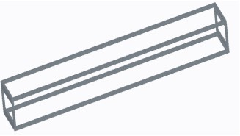

*Figure 1Base Platform CAD Model*

1. **Model the scissor arms:**

Design a pair of identical scissor arms using rectangular or trapezoidal shapes. These arms will be responsible for the vertical lifting motion of the scissor lift. The arms should be hinged at the base platform, allowing them to pivot.

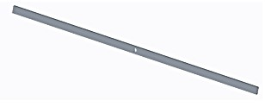

*Figure 2 Scissor Arm CAD Model*

1. **Connect the scissor arms:**

Attach the scissor arms together using pivot joints at their midpoints. The pivot joints should allow the scissor arms to fold and unfold as the lift operates.

1. **Create a lifting platform:**

Design a rectangular platform that is attached to the top of the scissor arms. This platform serves as the load-bearing surface and can be raised or lowered as the scissor arms move.

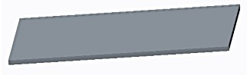

*Figure 3 Lifting Platform CAD Model*

1. **Add actuators:**

Integrate hydraulic cylinders or linear actuators at the base of the scissor arms. These actuators provide the force necessary to extend or retract the scissor arms, resulting in vertical motion of the lifting platform.

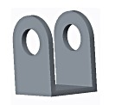

*Figure 4 Support Hinge CAD Model*

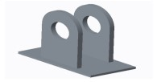

*Figure 5 Scissor Arm Hinge CAD Model*

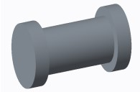

*Figure 6 Centre Pin CAD Model*

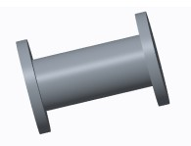

*Figure 7 Connector Pin CAD Model*

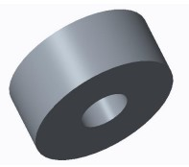

*Figure 8 Roller CAD Model*

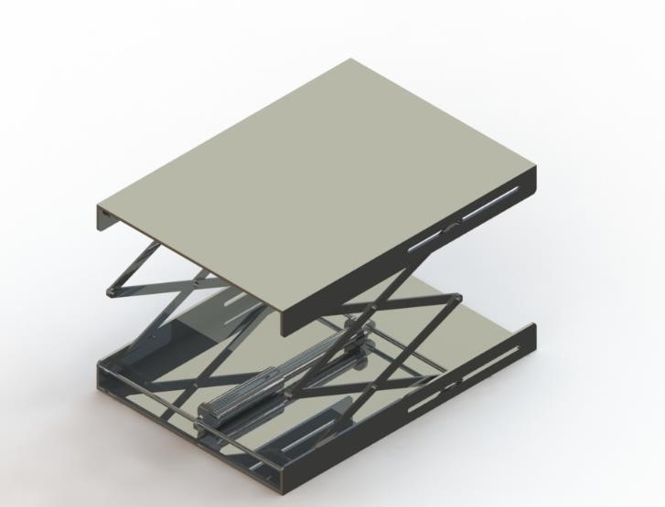

*Figure 9 CAD Model of Scissor Lift Mechanism*

## Finite Element Analysis – ANSYS

Performing a Finite Element Analysis (FEA) of a scissor lift mechanism involves simulating the structural behavior and stress distribution within the mechanism under different loading conditions. Static structural analysis was performed on the model. Static structural analysis is performed to evaluate the structural integrity, stress distribution, and deformation of a component or system under static loads. It helps identify critical areas prone to failure, assess the factor of safety, and optimize the design. By predicting stress levels, deformation, and displacement, engineers can validate the design, make informed decisions, and reduce development costs. Overall, static structural analysis ensures that the structure meets safety requirements, performs optimally, and fulfills its intended purpose.

1. **CAD Model Preparation:** First Create a detailed 3D CAD model of the scissor lift mechanism, including all components, joints, and connections on the *Solidworks* and uploaded the file on ANSYS.
2. **Material Properties:** Assign appropriate material properties to the components of the mechanism. Consider factors such as modulus of elasticity, Poisson's ratio, and yield strength. Mild Steel was selected as the appropriate material.
3. **Mesh Generation:** Divide the CAD model into a mesh of finite elements. The choice of element type (e.g., tetrahedral, hexahedral) and element size should be based on the complexity of the geometry and desired accuracy.

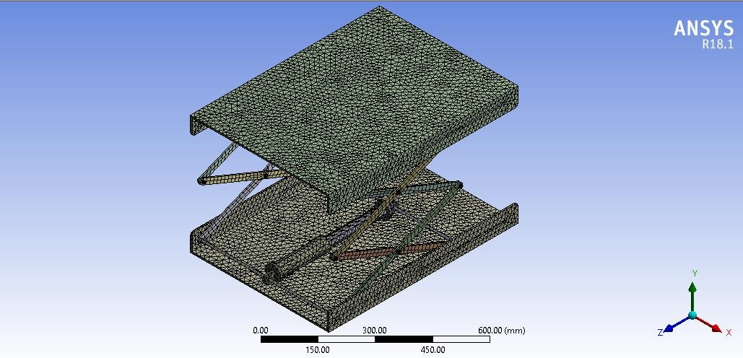

*Figure 10 Mesh Generation on Model*

1. **Boundary Conditions:** Define the constraints and boundary conditions in the FEA software. This includes fixing appropriate points or faces to represent the connections to the ground or supporting structure. A remote force of 51662 was applied on the top of the scissor lift mechanism. A fixed support boundary condition was applied on the bottom surface of the scissor lift mechanism.

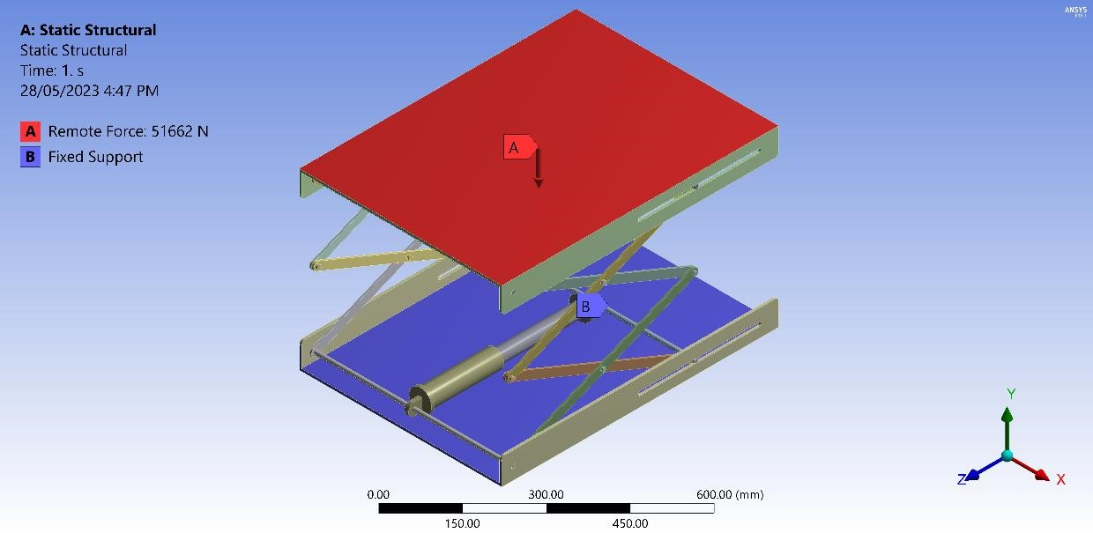

*Figure 11 Boundary Condition - Static Strucural*

1. **Load Application:** Apply the loads to the model based on the intended operating conditions. Consider the weight of the lifted load, dynamic forces, and other external loads that the scissor lift may encounter during operation.
2. **Analysis Setup:** Specify the type of analysis (static, dynamic, etc.) and select appropriate solution techniques within the FEA software. Define the appropriate solver settings and convergence criteria.
3. **Solve and Analyze:** Run the analysis to obtain the stress distribution, deformation, and other relevant results within the scissor lift mechanism. We also solved for the FOS.

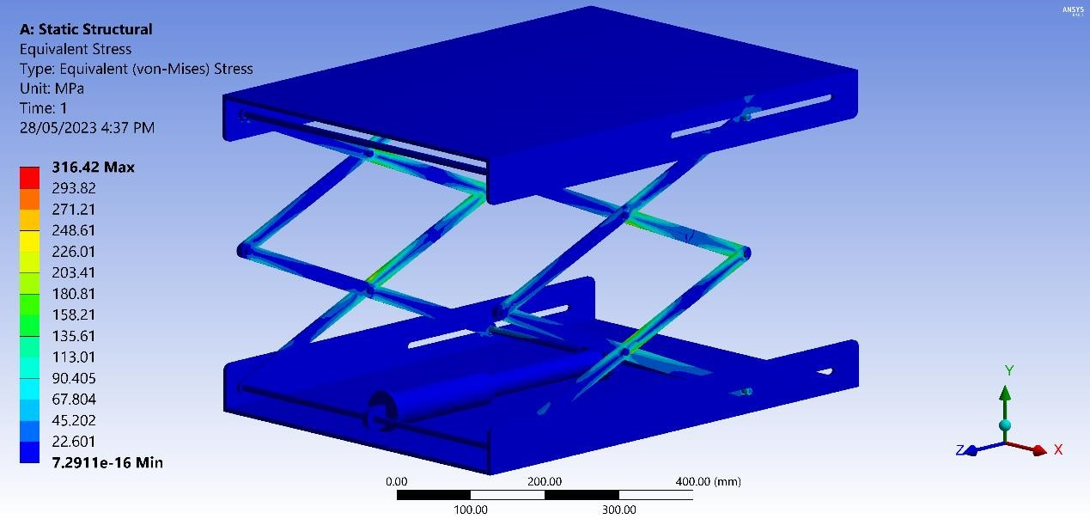

*Figure 12 Solution - Equivalent Stress*

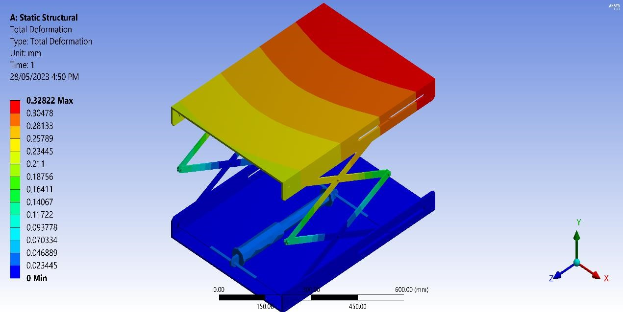

*Figure 13 Solution - Total Deformation*

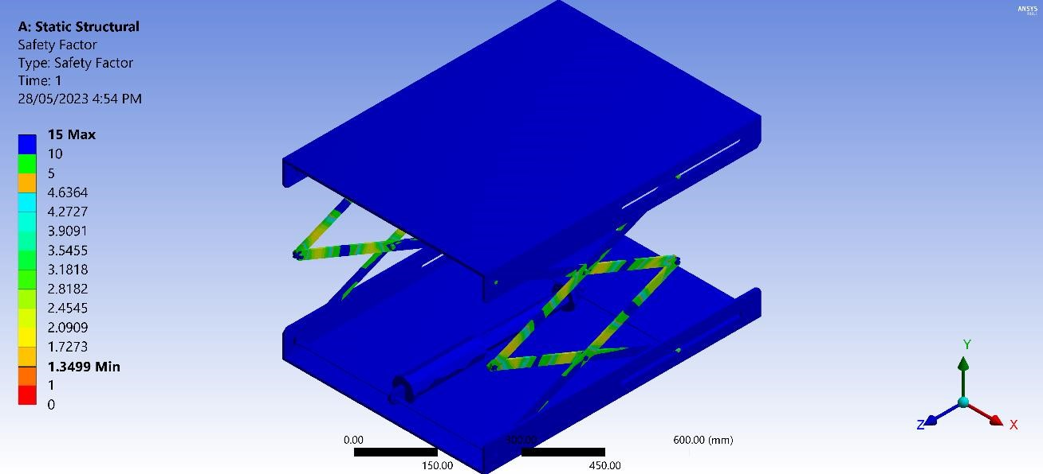

*Figure 14 Solution - Factor of Safety*

## Evaluation of Software Results

The static structural analysis results obtained from ANSYS for the given scenario are as follows:

1. **Maximum Equivalent Stress**

The maximum equivalent stress in the structure is **316.42 MPa**. This value represents the highest stress experienced by any point in the structure under the applied loads. It is important to compare this stress value with the material's yield strength to ensure that it remains within the allowable limits.

1. **Total Deformation**

The total deformation of the structure is measured to be **0.32822 mm**. This value represents the overall displacement or deformation of the structure under the applied loads.

It helps in assessing potential interference issues that may arise due to over deformation.

1. **Maximum Factor of Safety**

The maximum factor of safety calculated for the structure is **15**. This factor indicates the margin of safety in the design, with a higher value indicating a more robust and conservative design. A factor of safety of 15 suggests that the structure is capable of withstanding the applied loads with a considerable safety margin.

1. **Minimum Factor of Safety**

The minimum factor of safety calculated for the structure is **1.399**. This value represents the lowest factor of safety observed in any part of the structure. It is important to ensure that the minimum factor of safety remains above 1, indicating that the structure is designed to withstand the applied loads without exceeding the material's yield strength.

# Mesh Independence

We varied the mesh size from 60mm to 11.5mm until we got our mesh independence.

# Conclusion

In summary, the project on stress analysis of the scissor lift mechanism utilized both theoretical analysis and software simulation to evaluate its structural integrity and performance. The software results indicated a maximum equivalent stress of 316.42 MPa, a total deformation of 0.32822 mm, and a maximum factor of safety of 15. These findings suggest that the scissor lift mechanism is structurally sound and capable of withstanding the applied loads with a significant safety margin. However, further validation and adherence to industry standards are necessary to ensure the design's suitability for practical implementation. Overall, the combination of theoretical analysis and software simulation provided valuable insights into the design, helping optimize its performance and ensure its safety and reliability.

# Physical Applications

Physical Applications of Hydraulic Lift Scissor Arm are discussed below:

1. **Automotive maintenance:** Hydraulic scissor lift arms are commonly used in

automotive repair shops to lift vehicles for inspection, maintenance, and repairs. They provide a stable and secure platform for technicians to work underneath the vehicles.

1. **Warehousing and logistics:** Hydraulic scissor lift arms are used in warehouses and logistics facilities to lift and move heavy pallets or goods to different levels of racking systems. They make it easier to load and unload items at different heights.
2. **Construction:** Scissor lift arms are employed in construction sites to lift workers, tools, and materials to elevated heights. They are used for tasks such as installation, painting, wiring, and maintenance of structures.
3. **Manufacturing industry:** Hydraulic scissor lift arms find applications in the manufacturing sector for lifting heavy machinery, equipment, and components during assembly, maintenance, and repair processes.
4. **Loading docks:** Scissor lift arms are utilized in loading docks to facilitate the efficient loading and unloading of trucks. They enable workers to raise or lower the goods to match the height of the truck bed, improving productivity and safety.
5. **Aircraft maintenance:** Hydraulic scissor lift arms are used in aircraft hangars for maintenance, inspection, and repair work on airplanes. They provide a stable and elevated platform for technicians to access different parts of the aircraft.
6. **Exhibition and event setup:** Hydraulic scissor lift arms are employed in setting up stages, lighting systems, and other equipment for exhibitions, concerts, and events.

They enable workers to reach heights safely and efficiently.

1. **Hospital and healthcare:** Hydraulic scissor lift arms are used in healthcare facilities for patient lifting and transfer. They assist in safely moving patients between beds, wheelchairs, and other medical equipment.
2. **Retail and inventory management:** Scissor lift arms are utilized in retail stores and warehouses for inventory management. They help store personnel access goods stored at higher levels, improving efficiency in stocking and retrieving items.
3. **Agriculture:** Hydraulic scissor lift arms find applications in agriculture for tasks such as maintenance and repair of farm equipment, handling and loading of agricultural products, and accessing elevated areas for crop management.

These are just a few examples of the various physical applications of hydraulic scissor lift arms across different industries. Their versatility and ability to provide safe and efficient vertical movement make them valuable tools in many different settings.

# References

[1]. M.Kiran Kumar, J.Chandrashekhar, Mahipal Manda, D.vijay Kumar (2016), Design & Analysis of Hydraulic Scissor Lift. IRJET Vol.3 page.1647.

[2]. Jaydeep M. Bhatt, Milan J. Pandya(2013), Design and Analysis of an Aerial Scissor Lift, Journal of information, knowledge and research in mechanical engineering,Vol.02 Page 452.

[3]. Georgy Olenin,(2016) Design of hydraulic scissor lifting platform, Saimaa University Of Applied Sciences Lappeenranta, Page no.13-14.

[4]. Gaffar G. Momin, Rohan Hatti, Karan Dalvi, Faisal Bargi, Rohit Devare,(2015), Design,

Manufacturing & Analysis of Hydraulic Scissor Lift,IJERGS, Vol.3 Page 735-738